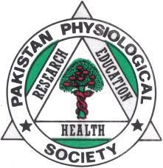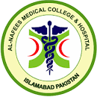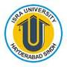

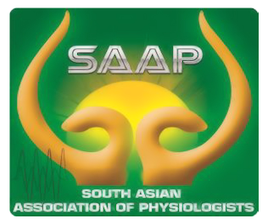

**Regional Journal Club**

**Pakistan Physiological Society**

**Rawalpindi & Islamabad Twin cities**

**Title: *Presenting Journal Club***

**Date: 29th February, 2024**

**Day: Thursday.**

**Venue: Al- Nafees Medical College, Isra University Islamabad**

**Campus, Lehtrar road, Farash town**

**Timings: 10:00 am to 11::30 am**

**Mode: Hybrid (Zoom link will be shared later)**

**Guest Speaker: (10 minutes)**

* *Prof Maj.Gen.(Retd) Dr.Muhammad Aslam*

**Speaker later (15 minutes)**

* *Prof Dr Umar Ali Khan Pro Vice Chancellor Isra university Islamabad Campus & Past President PPS.*

**Participants:**

All faculty of Physiology from Medical Colleges of Rawalpindi & Islamabad are cordially invited to attend the Journal club on above venue.

For any query email at munazza_wah@yahoo.com